***1. Introduction***

In technical terms, Gait is a pattern of limb movements that is made during locomotion. In layman terms, Gait refers to the way in which a person walks. This repetitive pattern consists of steps and strides. A ‘stride’ refers to a whole gait cycle. A gait cycle basically consists of two phases which is the ‘stance’ phase and the ‘swing’ phase. The ‘stance’ phase starts when the heel strike’s the ground and the toe leave the ground. The ‘swing’ phase starts when the toe leaves the ground and the heel touches the ground. Basically the ‘swing’ phase begins when the ‘stance’ phase ends.

The main purpose of this assignment (and also the problem given) is to filter out the noises that are causing irregularities (oscillations) within the signal by using the knowledge that we have learned throughout this unit. This signal is given and it represents the total vertical ground reaction force (VGRF) under each foot recorded in Newton and sampled at 120Hz. After filtering this signal, we can obtain the filtered VGRF signal to measure the stance and the swing time. This means that we can estimate the sequence of stance times, swing times and stride times for each foot from the noisy VGRF data (after filtering the signal). The stride time is obtained through the summation of the stance time and the swing time after one cycle.

***2. Data Exploration***

**a. *Section 3.1***

***Part 1***

The 5-second segment of data is shown in figure 1 below. We can deduce that there are around 4 gait cycles just through visual observation within a 5 second interval of the given signal. From figure 2 and figure 3, we can see that there is a noise signal present at around 50Hz.

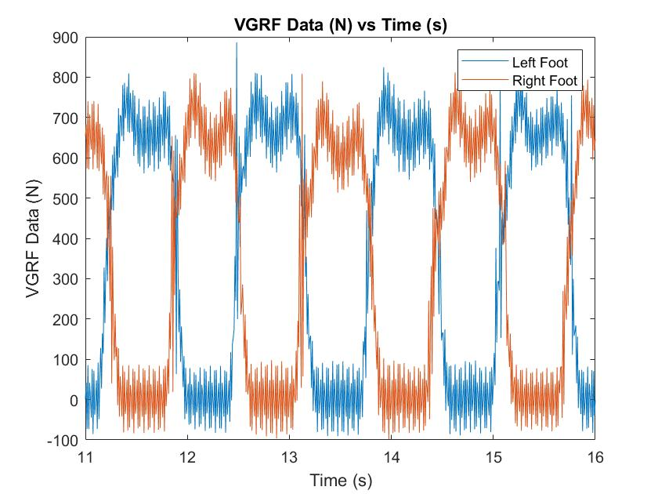

*Fig1: Plot of VGRF signal for left foot and right foot*

***Part 2***

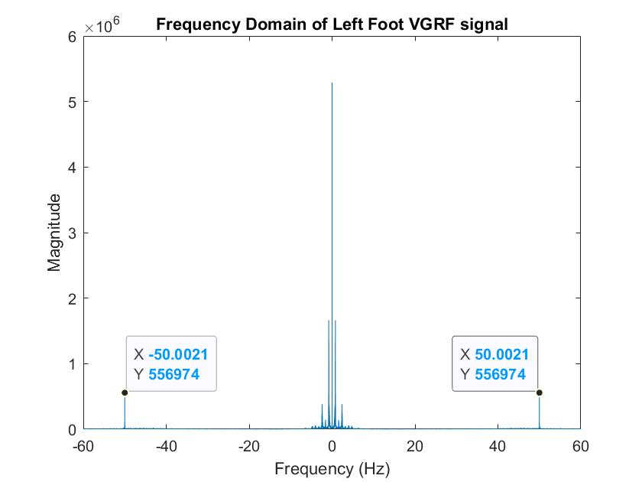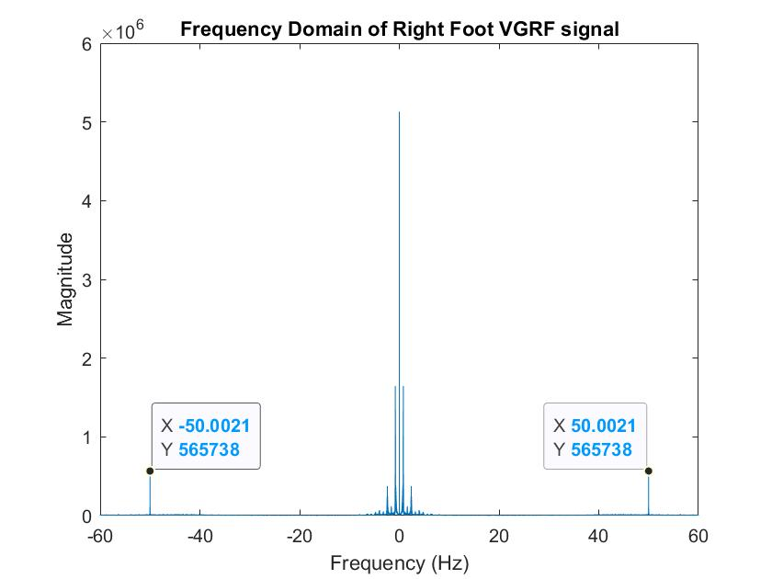

*Fig2: Frequency Domain of the Left Foot Fig3: Frequency Domain of the right foot*

***Part 3***

***Question 3.1 Answer***

No, we cannot find a simple threshold in the VGRF value. This is because the signal given consists of noise that blurs the transition between the swing and the stance phase. This could be due to some part of the noise having the same amplitude when the leg is lifted off the ground. This means that if we filter out the signal (noise), we could potentially filter off the signal that is essential to the analysis of our signal, leading to inaccurate calculation of the gait cycle which would lead us to make inaccurate predictions.

***b. Section 3.2***

***Part 1***

The spectrogram for the signal is plotted in figure 4, 5 and 6. Time Frequency Analysis is performed on the left foot VGRF signal for 30 seconds using the MATLAB built-in function spectrogram. The stance and the swing phase are plotted and labelled. As we can observed from the figure below, we can see that the power is focused around the frequency range of 0 to 5 Hz and also around the 47-55 Hz range. This observation is similar to the observations made in section 3.1.

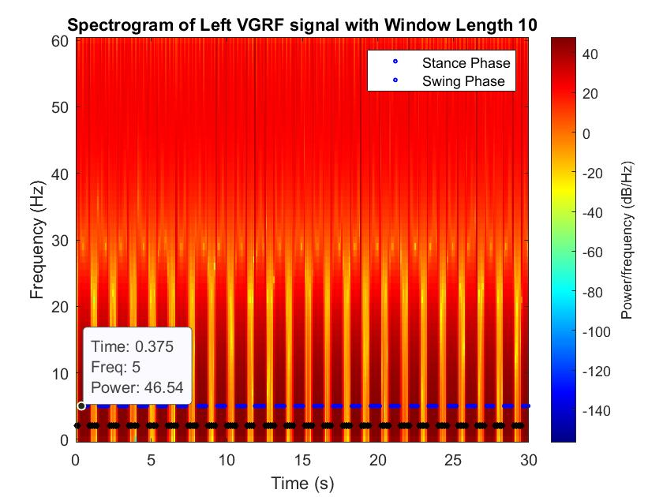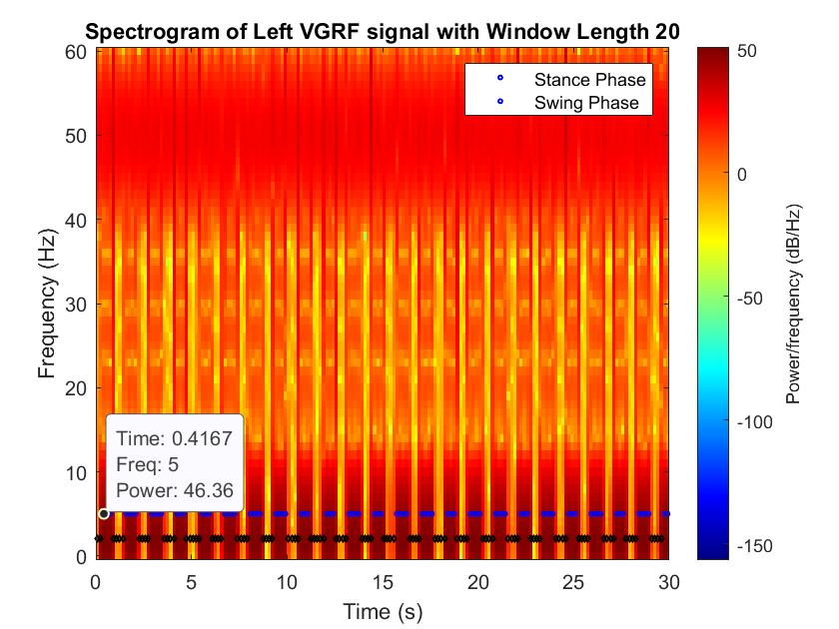

*Fig4: Plot of Spectrogram of Left VGRF Signal (Window Length 10) Fig5: Plot of Spectrogram of Left VGRF Signal (Window Length 20)*

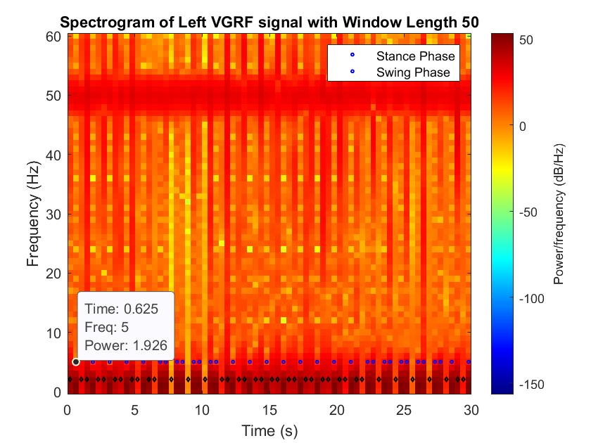

*Fig6: Plot of Spectrogram of Left VGRF Signal (Window Length 50)*

***Part 2***

***Question 3.2a Answer***

From visual observation of the spectrogram that we have plotted above, we can observe that when the window length is increased, the spectrogram will become more blur. This is because as the number of the samples increase, the resolution

will decrease as the frequency content is an accumulation of each sub-phases of the stance and the swing phase. When the window length is decreased, we can visualize the stance and the swing phase of the foot in a much clearer picture, allowing us to make a better prediction.

***Part 3***

***Question 3.2b Answer***

The main noise component can be pinpointed to the window length of 50 just by plotting the spectrogram and relying on visual observation alone. The power noise at around the 47-55 Hz (Mainly at 50Hz). One major source of noise would be the power line interference.

***3. Filtering***

The estimateGait.m function file will be doing the filtering, finding the time at which each swing and stance phase starts for each foot and computing the sequence of swing and stance and stride times.

The filter suitable to use for the given signal would be a low pass filter. In this case, the low pass filter will have an order of 200 (Length of 201). The most suitable transition band will be 10Hz and 15Hz. The filter is constructed by using the MATLAB function firpm which takes in the order of the filter, a range of frequencies in terms of π and the amplitude of the frequencies. After using the firpm function, the conv built-in MATLAB function is used to filter the noisy signal.

The reason why a low pass filter is selected instead of other filters is due to the fact that the important part of the signal is located at a lower frequency (mostly around 0-5Hz). The majority of the noise signal is located at a high frequency (around the range of 46-53 Hz) as we can see in the figure below. The transition band should be chosen around the range of the important part of the signal and must avoid destructing the important part of the signal. The process of choosing the transition band is based on the visual observation of the signal by plotting out the signal based on the different values of the transition band and checking which transition band can better filter out the signal.

***Question 3.3a Answer***

The plot of the filtered signal in the time domain looks much smoother and does not consist of irregular oscillations compared with the original signal. The filtered signal overall looks much cleaner.

***Question 3.3b Answer***

The plot of the filtered signal in the frequency domain looks different. The noise signal greater than 15Hz is removed, leaving only the frequency of the signal that consists of important information.

*The plots of the filtered signal in the time and frequency domain are shown in Figure 7, 8 and 9.*

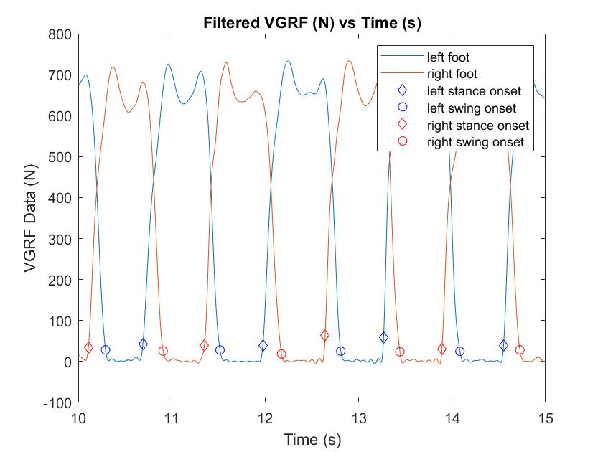

*Fig7: Plot of VGRF filtered signal for left foot and right foot*

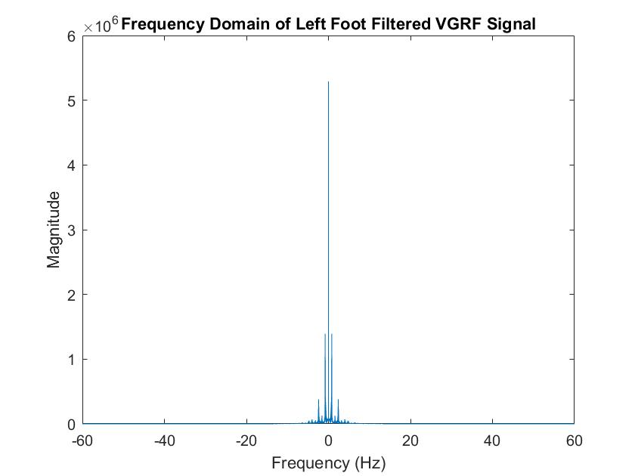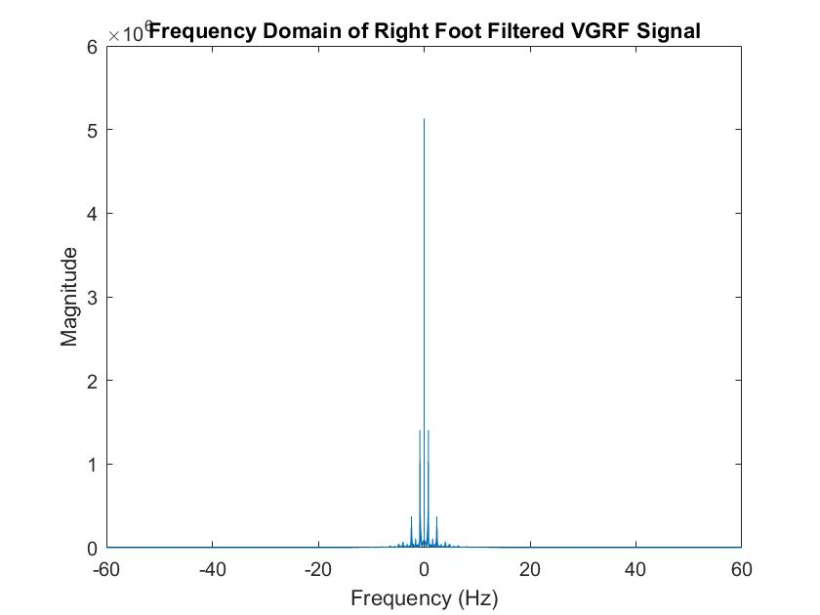

*Fig8: Frequency Domain of the Left Foot VGRF Filtered Signal Fig9: Frequency Domain of the Right Foot VGRF Filtered Signal*

**4. Computing Gait Parameters**

To find the sequence of swing, stance and stride times, we need to compute the duration of the swing onset and the stance onset. The function that I have written which is estimateGait.m will automatically compute the onset time. A threshold value is set in the function (to separate the swing and the stance phase). This value is obtained through the visual observation of the of the plots in particular the swing and the stance phase for each leg. The logic behind this is that if the signal is below the threshold, then the signal should be in the swing phase. If the signal is above the threshold, then the signal will be in the stance phase. From visual observation of the plots, we can see that the swing onset is found first.

The logic behind my code is that we begin with getting the data from the user. The data will then be extracted into its respective categories. A low pass filter will be created within the function itself and the data for the left foot and the right foot will undergo convolution for filtering. We then get the starting index of the left foot. The swing and the stance phase value will be obtained periodically, meaning that once the swing phase is obtained, we will start to find for the stance phase. This is done by going through the filtered data and a for loop with an if-elseif condition. After this, the swing and the stance onset time is obtained. From here, we would need to get the index of all of the values obtained using the find

MATLAB built-in function. Once the index is obtained, we then can find the stance duration, swing duration and the strides duration. The stance duration would be the swing index minus the stance index divided by the sampling frequency of 120Hz. The swing duration would be the stance index minus the swing index divided by the sampling frequency. The stride duration can be directly obtained from the stance index since the stride durations is just the summation of the stance and the swing durations.

The above process is repeated for the data of the right foot with the same assumption that the swing onset is found first.

The gait parameter calculations would be the same for both of the data of the legs.

The plot for the stance time, swing time and stride time of both the left foot and right foot are plotted in the three different subplots below.

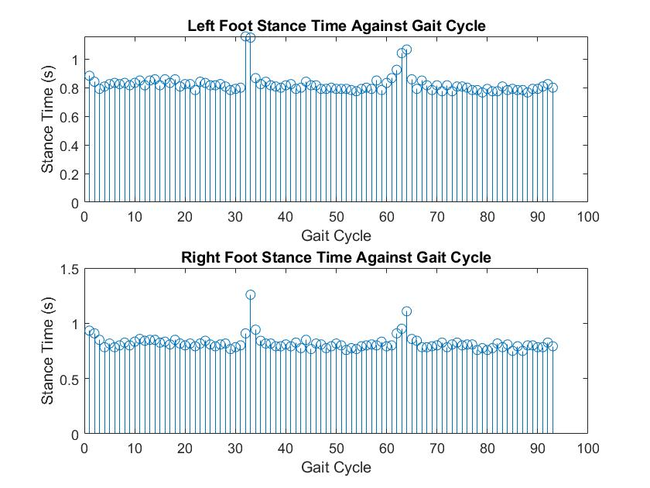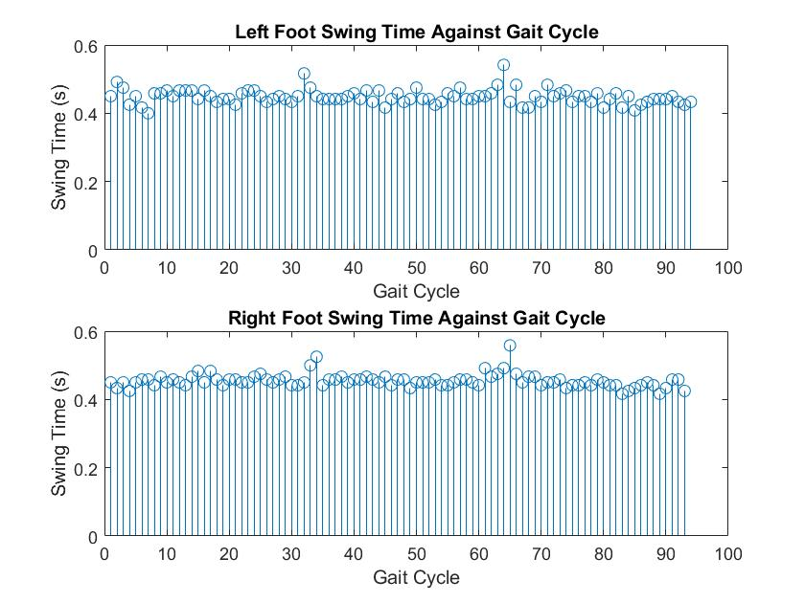

*Fig10: Left Foot and Right Foot Stance Time vs Gait Cycle Fig11: Left Foot and Right Foot Swing Time vs Gait Cycle*

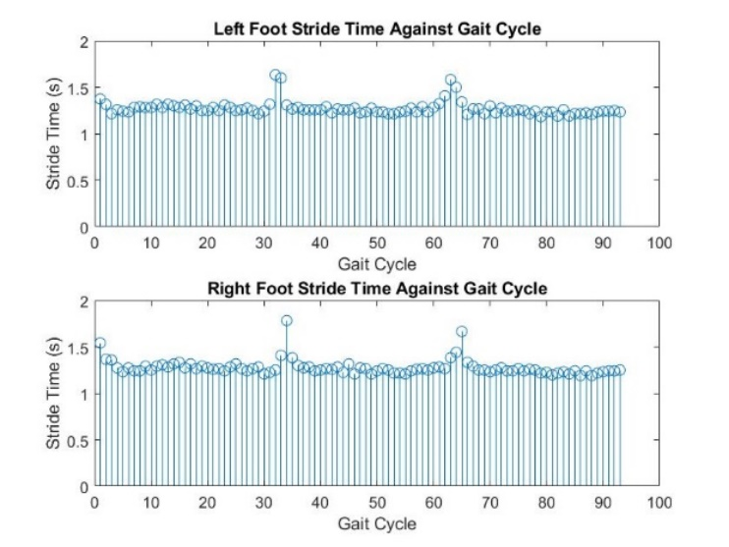

*Fig12: Left Foot and Right Foot Stride Time vs Gait Cycle*